Book

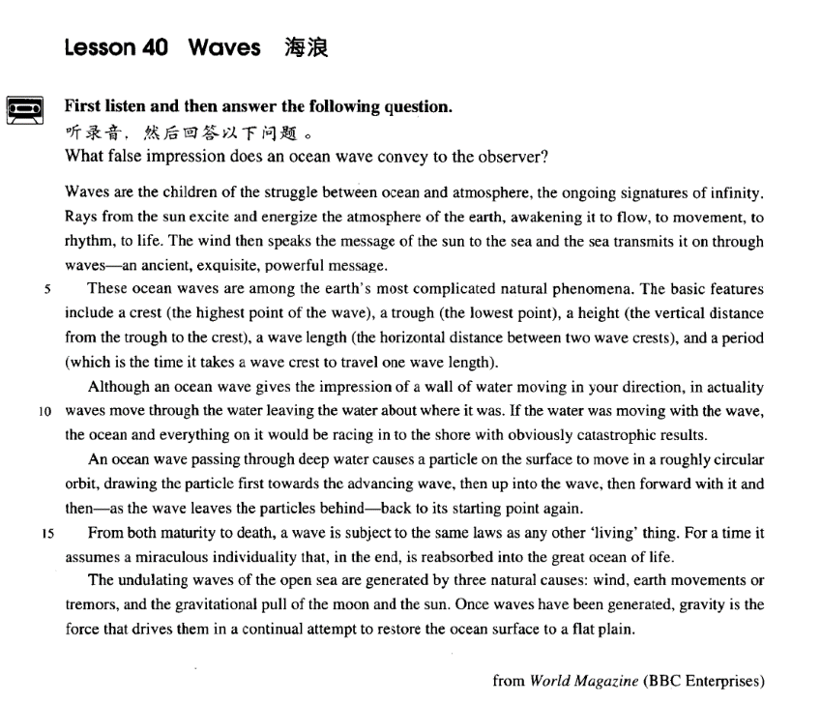

课文

Waves are the children of the struggle between ocean and atmosphere, the ongoing signatures of infinity.

海浪是大海和空气相斗的产物，无限的一种不间断的标志。

Rays from the sun excite and energize the atmosphere of the earth, awakening it to flow, to movement, to rhythm, to life.

太阳光刺激了地球的大气层，并给予它能量；阳光使空气开始流动，产生节奏，获得生命。

The wind then speaks the message of the sun to the sea and the sea transmits it on through waves -- an ancient, exquisite powerful message.

然后，风把太阳的住处带给了大海，海洋用波浪的形式传递这个信息 -- 一个源过流长、高雅而有力的信息。

These ocean waves are among the earth's most complicated natural phenomena.

这些海浪属于地球上最复杂的自然现象。

The basic features include a crest (the highest point of the wave),

它们的基本特征包括浪峰（波浪的最高点）、

a trough (the lowest point), a height (the vertical distance from the trough to the crest),

波谷（最低点）、浪高（从波谷到浪峰的垂直距离）、

a wave length (the horizontal distance between two wave crests),

波长（两个浪峰间的水平距离）

and a period (which is the time it takes awave crest to travel one wave length).

和周期（海峰走过一个波长所需的时间）。

Although an ocean wave gives the impression of a wall of water moving in your direction,

虽然，海浪给人的印象是一堵由水组成的墙向你压过来，

in actuality waves move through the water leaving the water about where it was.

而实际上，浪从水中移过，而水则留在原处。

If the water was moving with the wave, the ocean and everything on it would be racing in to the shore with obviously catastrophic results.

如果水和浪一起移动的话，那么大海和海里所有的东西就会向岸边疾涌过来，带来明显的灾难性后果。

An ocean wave passing through deep water causes a particle on the surface to move in a roughly circular orbit, drawing the particle first towards the advancing wave, then up into the wave, then forward with it and then -- as the wave leaves the particles behind -- back to its starting point again.

穿过深水的海浪使水面上的一个微粒按照一种近乎圆形的轨道移动，先把微粒拉向前移动的海浪，然后推上波浪，随着波浪移动，然后 -- 当波浪把微粒留在身后时 -- 又回到出发点。

From both maturity to death, a wave is subject to the same laws as any other 'living' thing.

从成熟到消亡，波浪和其他任何“活动中”的东西一样，都受制于共同的法则。

For a time it assumes a miraculous individuality that, in the end, is reabsorbed into the great ocean of life.

一度它获得非凡的个性，但最终又被重新融进生命的大洋。

The undulating waves of the open sea are generated by three natural causes: wind, earth movements or tremors, and the gravitational pull of the moon and the sun.

公海上起伏的波浪是由3个自然因素构成的：风、地球的运动或震颤和月亮、太阳的引力。

Once waves have been generated, gravity is the force that drives them in a continual attempt to restore the ocean surface to a flat plain.

一旦波浪形成，地球引力是持续不断企图使海面复原为平面的力量。

词汇讲解

Lesson 40 Waves

infinity [ɪn'fɪnəti]

n. 无限的时间或空间，无穷远

infinity n. [U] a space, time, or distance that continues without end or limits 无限的时间或空间，无穷远

the infinity of space

a barren landscape stretching into infinity

“fin” = to end

finale n. 终曲，结局finalize v. 使完成，使结束finite adj. 有限的

infinite “in” = not adj. 无限的

infinity n. 无限的时间或空间，无穷远infinitive n.（动词）原形，不定式confine “con” = together v. 限制；拘禁confinement n. 限制；拘禁

define “de” = down v. 下定义

definition n. 定义definite adj. 明确的indefinite adj. 不明确的

definitive adj. 最终的；最好的；确定无疑的

refine “re” = again v. 提炼；改良refined adj. 精炼的；文雅的refinement n. 精炼；文雅transmit [træns'mɪt]

v. 传输；传播

transmit v. 1. to send an electronic signal, radio or television broadcast, etc. 传输（信号，节目等）

The ceremony was transmitted live by satellite to over fifty countries. transmit v. 2. to pass sth. from one person to another 将某事物传送、传递、传达或传染给对方

sexually transmitted diseases

transmit knowledge from one generation to another

The tension soon transmitted itself to all the members of the crowd. “mit” / “miss” = send

intermit “inter” = between v. 暂停

intermittent adj. 断续的；间歇的intermission n. 暂停；幕间休息admit “ad” = to v. 准许进入；承认admission n. 准许进入；承认emit “e” = out v. 发射，发出emission n. 发射，发出

omit “o” / “ob” = away v. 省略，删除；忽略，疏忽

omission n.省略，删除；忽略，疏忽permit “per” = through v.允许permission n. 允许

submit “sub” = under v. 提交，上交；服从，屈服submission n. 提交，上交；服从，屈服submissive adj. 服从的，顺从的

transmit “trans” = across v. 传输；传染

transmission n. 传输；传染

remit “re” = back v. 赦免，宽恕；汇款

remission n. 赦免，宽恕

remittance n. 汇款

manumit “manu” = hand v. 解放（奴隶） manumission n.（奴隶的）解放exquisite

[ɪk'skwɪzɪt] ['ɛkskwɪzɪt]

adj. 精致的；高雅的

exquisite adj. 1. extremely beautiful and very delicately made 精致的

exquisite craftsmanship

Her wedding dress was absolutely exquisite.

exquisite adj. 2. very sensitive and delicate in the way you behave or do things 高雅的

She has exquisite taste in art.

“quire” / “quisit” / “quest” = to seek exquisite “ex” = out adj. 精致的；高雅的inquire “in” = into v. 询问，打听

inquest n.（对死因的）调查

inquisition n. 盘问；宗教法庭

inquisitive adj. 好奇的；爱打听的

acquire “ac” = to v. 获得，取得acquisition n. 获得；获得物acquisitive adj. 贪婪的

perquisite “per” = thoroughly n. 特权；额外收入

requisite “re” = again n. 必需品；adj. 必须的

prerequisite “pre” = before n. 先决条件，前提；adj. 必备的，作为先决条件的

requisition n. 征用；v. 征用

disquisition “dis” = apart n. 专题论文；专题演讲

phenomena [fə'nɒmɪnə]

n. 现象（复数）

phenomenon n. (pl phenomena) a fact or an event in nature or society, especially one that is not fully understood 现象

natural / social / historical phenomena

An eclipse of the moon is a rare phenomenon.

Early retirement is a relatively new phenomenon in Britain. phenomenon → phenomena

criterion → criteria medium → media datum → data stratum → strata

bacterium → bacteria curriculum → curricula

catastrophic [7kætə'strɒfɪk]

adj. 灾难性的

catastrophic adj. causing a lot of damage or making a lot of people suffer

= disastrous 灾难性的

catastrophic floods

a catastrophic fall in the price of rice

The failure of the talks could have catastrophic consequences . catastrophe n. 特大灾难

The telephone rings and this marks the prelude to an unforeseen series of

catastrophes. mishap

accident contingency

disaster

calamity catastrophe

maturity [mə'tʃʊərəti]

n.（心理或生理）成熟

maturity n. 1. [U] the quality of behaving in a sensible way like an adult

（心理）成熟

He has maturity beyond his years.

One day you will have the maturity to understand.

maturity n. 2. [U] (of a person, an animal, or a plant) the state of being fully grown or developed（生理）成熟

The forest will take 100 years to reach maturity.

How long does it take for the chicks to grow to maturity? mature adj.（心理或生理）成熟的

Laura is very mature for her age .

Mature apple trees are typically 20 feet tall. adult / full-grown adj.（生理）成熟的 an adult cat

A full-grown giraffe is 5.5 m tall.

ripe adj. 水果或庄稼成熟的；时机成熟的

Soon ripe, soon rotten.

I'm waiting till the time is ripe before I tell my parents that I failed my exams.

well-done adj. 全熟的

medium well adj. 七八分熟的medium adj. 五分熟的medium rare adj. 四分熟的a rare adj. 三分熟的

How would you like your steak cooked?

I’d like my steak well-done / medium well / medium / medium rare / rare. Monica: Okay, now this one is rare, this one is medium well! Now go-go-go! Hey Phoebe!

Phoebe: Hey!

Monica: Hey how was dinner?! Phoebe: Dinner was good!

raw adj. 全生的

I like to eat fish raw.

Waves are the children *of the struggle between ocean and atmosphere*, the

ongoing signatures *of infinity*. child of … ……的产物

The atomic bomb is the child of 20th century scientific developments.

The romantic movement was the child of the Great Revolution. the struggle *between* good *and* evil

ongoing adj. continuing to exist or develop 持续（存在或发展）的

an ongoing debate / discussion / process

The police investigation is ongoing.

Training is part of our ongoing career development program.

Rays *from the sun* excite and energize the atmosphere of the earth, awakening it to flow, to movement, to rhythm, to life.

ray n. [C] a straight narrow beam of light from the sun or moon 光线

X-rays

ultraviolet rays

The room darkened as a cloud hid the sun's rays.

energize v. to make someone feel full of energy or enthusiasm 使某人充满能量或热情

a refreshing and energizing fruit drink

awaken sb. to sth.: cause sb. to become aware of sth. 使某人意识到某事

awaken society to the dangers of drugs

During the 1930s Churchill tried to awaken the British people to the need for rearmament.

It has awakened millions to political consciousness and recognition of the danger of fascism.

rhythm n. [U and C] 节奏

the steady rhythm *of* her heartbeat

She started moving *to* the rhythm *of* the music.

The wind then speaks the message of the sun to the sea and the sea transmits it on *through waves* ― an ancient, exquisite, powerful message. speak v. to say or state sth.

She was clearly speaking the truth. He spoke the final words of the play.

He spoke only two words the whole evening.

These ocean waves are *among the earth's most complicated natural*

*phenomena*.

be among … 是……之一；包括在……之中

He was among the last to leave.

Among those present were the Prime Minister and her husband.

The basic features include a crest *(the highest point of the wave)*, a trough

*(the lowest point)*, a height *(the vertical distance from the trough to the*

*crest)*, a wave length *(the horizontal distance between two wave crests)*, and a period *(which is the time it takes a wave crest to travel one wave*

*length)*.

crest n. the top or highest point of something such as a hill or a wave 山峰，浪尖

crest of …

It took us over an hour to reach the crest of the hill. surfers riding the crest of the wave

trough n. the hollow area between two waves 波谷

…, and a period (*which is the time (which) it takes a wave crest to travel*

*one wave length*).

Although an ocean wave gives the impression *of a wall of water moving*

*in your direction*, in actuality waves move through the water leaving the water about where it was.

give (sb.) the impression (that) …: 使（某）人觉得……，给（某）人

的印象是……

He gives the impression that he really doesn't care.

The sudden movement of the door made it sway slightly and it gave me the impression that it was about to leap out at me.

be under the impression (that) …: to believe that sth. is true when it is not

误以为……

I'm sorry, I was under the impression that you were the manager.

Though the crew were at first under the impression that the lost ship had been found, the contents of the sea-chest proved them wrong.

wall n. thing similar to a wall in its appearance or effect （样子或作用）

似墙之物

wall of fire / water …

Firefighters battled the walls of flames.

The investigators were confronted by a wall of silence. The tidal wave formed a terrifying wall of water.

The Titanic turned just in time, narrowly missing the immense wall of ice which rose over 100 feet out of the water beside her.

*a boy* of a girl

*an angel* of a wife

*a palace* of a house

*a garden* of Switzerland

Jane is *a submissive lamb* of a girl.

There is always hope that in its *labyrinth* of *musty, dark, disordered*

*rooms* a real rarity will be found amongst the piles of assorted junk that

litter the floors. in sb.'s direction

Fortunately for me, as I was wondering what to do next, there appeared on the horizon a man on horseback, riding in my direction.

in the direction of …

Tom went off in the direction of the post office. in every direction / in all directions

It is a harmless habit, but it litters up her desk to such an extent that every time she opens it, loose bits of paper fall out in every direction.

The elephant is not immediately susceptible to such blandishments, however, and usually lashes fiercely with its trunk in all directions.

in actuality = in reality / actually 事实上

In actuality, it's much more complex than that.

The woman he had seen performing on stage was in actuality quite older than she had seemed.

If the water was moving with the wave, the ocean and everything on it would be racing in to the shore *with obviously catastrophic results*.

If she was here, she could speak on my behalf. If I was rich, I would buy you anything.

If it was to rain, the ropes would snap. if I were you

were I you

as it were

if it were not for were it not for

An ocean wave passing through deep water causes a particle on the

surface to move *in a roughly circular orbit*, drawing the particle first

towards the advancing wave, then up into the wave, then forward with it

and then *― as the wave leaves the particles behind ―* back to its starting

point again.

particle n. [C] a very small piece of sth. 微粒

dust particles

tiny particles of soil

From both maturity to death, a wave is subject to the same laws *as any*

*other 'living' thing*.

be subject to …: 1. if you are subject to a rule, law, penalty etc, you must obey the rule or pay an amount of money 必须服从或支付

As a diplomat, he is not subject to local laws.

Violators are subject to a $100 fine. Cars are subject to a high domestic tax.

be subject to …: 2. often having, suffering or undergoing sth 常有、常患

或常遭某事物

Are you subject to colds?

Trains are subject to delays after the heavy snowfalls.

The timetable is subject to alteration.

be subject to …: 3. depending on sth. as a condition 需要某事物（为先决条件），取决于……

The plan is subject to the director's approval.

Goods will be sent out within 14 days, subject to availability.

So let us begin anew—remembering on both sides that civility is not a sign of weakness, and sincerity is always subject to proof. Let us never negotiate out of fear, but let us never fear to negotiate.

— John F. Kennedy

From both maturity to death, a wave is subject to the same laws as any other 'living' thing (is).

From both maturity to death, a wave is subject to the same laws as (is) any other 'living' thing.

For a time it assumes a miraculous individuality that, *in the end*, is reabsorbed into the great ocean of life.

for a time: temporarily, for a certain period 暂时，一时，一度

This method was used for a time, but it is no use now． He was for a time a professor at Cambridge．

assume v. (fml.) to start to have a particular quality or appearance = take on 开始拥有（某种特征或外表）

These relationships assume great importance in times of crisis.

In the story the god assumes the form of an eagle.

individuality n. [U] the qualities that make sb. or sth. different from other things or people 个性，个人特征

We like our staff to show their individuality rather than wear a uniform.

The plot is credible but the characters lack individuality. reabsorb v. to absorb again 再次吸收，使再次融入reabsorb … into …

The economy cannot reabsorb all of the refugees into the workforce.

The undulating waves of the open sea are generated by three natural

causes: wind, earth movements or tremors, and the gravitational pull of

the moon and the sun.

undulate v. (fml.) to move or be shaped like waves that are rising and falling 波动，呈波浪状起伏

undulating hills

a field of wheat undulating in the breeze

tremor n. 1. a small earthquake in which the ground shakes slightly 轻 微地震

an earth tremor

tremor n. 2. a slight shaking movement in your body that you cannot control, especially because you are ill, weak, or upset 颤抖

There was a slight tremor in his voice.

She felt a tremor of fear run through her.

gravitational adj. related to or resulting from the force of gravity 重力的

gravitational field 重力场

gravitational pull 引力

Once waves have been generated, gravity is the force *that drives them in*

*a continual attempt to restore the ocean surface to a flat plain*. restore sth. to sth.

The government promises to restore the economy to full strength.

She was hoping that the Mediterranean climate would restore her to full health.